**Problem 1:** You are asked to design a database for an online learning website.

Business Rules:

1. A student may take as many online courses as he/she wants.
2. An online course may be taken by any number of students.
3. Each student must rate the course that he/she takes using a like-scale from 1 to 5.
4. Thus, the *popularity* of a course is calculated based on the average scores rated by the students.

*Additional Business Rules:*

1. There can exist a student who does not take any online course.
2. There can exist an online course not taken by any student.
3. The attribute Popularity in the OnlineCourse table is derived by calculating the average of Rating attribute values for a particular CourseID in the CourseRecord table.
4. PhoneNumber is considered a simple attribute (Primary Phone Number).
5. The Rating attribute in CourseRecord can have values only between 1 to 5, with 5 as the highest rating.

***ER Diagram***

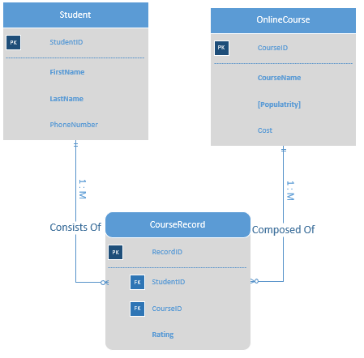

*Entities:*

1. Student:

a) Primary Key: **StudentID**

b) Required Attributes: **FirstName, LastName**

c) Optional Attributes: PhoneNumber

1. OnlineCourse:

a) Primary Key: **CourseID**

b) Required Attributes: **CourseName**

c) Optional Attributes: Cost

d) Derived Attributes: **[Popularity]**

Associative Entity:

1. CourseRecord:

a) Primary Key: **RecordID**

b) Foreign Key: StudentID, CourseID

c) Required Attributes: **Rating**

**Access Tables**

1. **Datasheet views:**

**Student Table**

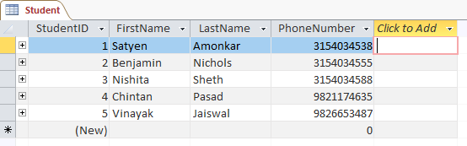**OnlineCourse Table**

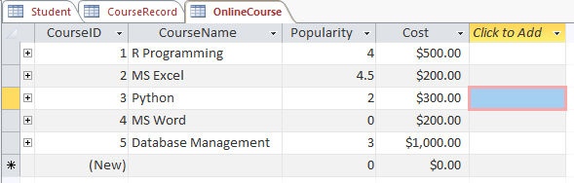

**CourseRecord Table**

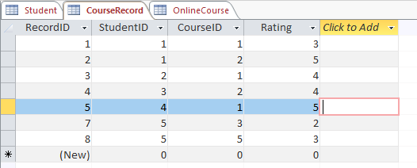

1. **Data Relationship Model**

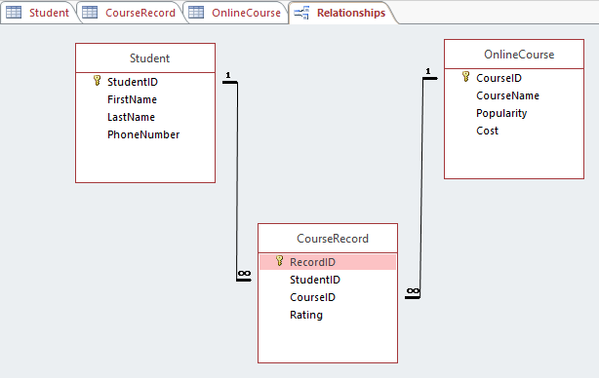

**Problem 2:**

**Ternary Relationship**: User watches show on channel.

**Business Rule:** A user may or may not watch several shows. A user may or may not watch several channels. A channel can be watched by several users. A channel can have many shows.

A show can be watched by many users. A show can be shown on many channels.

*Additional Business Rules:*

1. There can exist a user who does not watch any shows.
2. There can exist a user who does not watch any channel.
3. There can exist a channel which is not watched by any user.
4. There can exist a channel which does not have any show.
5. There can exist a show which is not watched by any user.
6. There can exist a show which is not shown on any channel.
7. ChannelRating in Channel table is scaled from 1 to 5, with 5 as the highest rating.
8. ShowRating in Show table is scaled from 1 to 10, with 10 as the highest rating.

**ER Diagram**

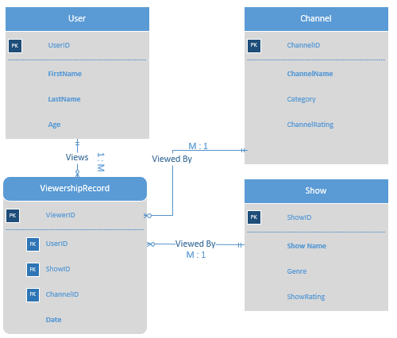

*Entities:*

1. User:

a) Primary Key: **UserID**

b) Required Attributes: **FirstName, LastName, Age**

1. Channel:

a) Primary Key: **ChannelID**

b) Required Attributes: **ChannelName**

c) Optional Attributes: Category, ChannelRating

1. Show:

a) Primary Key: **ShowID**

b) Required Attributes: **ShowName**

c) Optional Attributes: Genre, ShowRating

Associative Entity:

1. ViewershipRecord:

a) Primary Key: **ViewershipID**

b) Foreign Key: UserID, ShowID, ChannelID

c) Required Attributes: **Date**

**Access Tables**

1. **Datasheet views:**

**User Table**

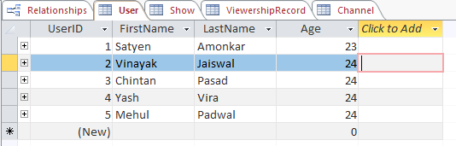

**Show Table**

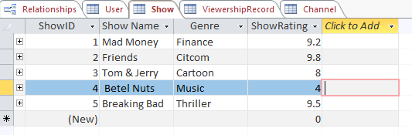

**Channel Table**

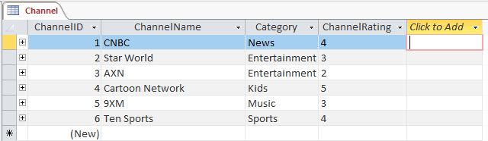

**ViewershipRecord Table**

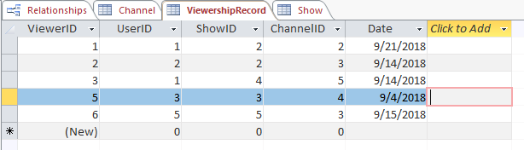

1. **Data Relationship Model**

